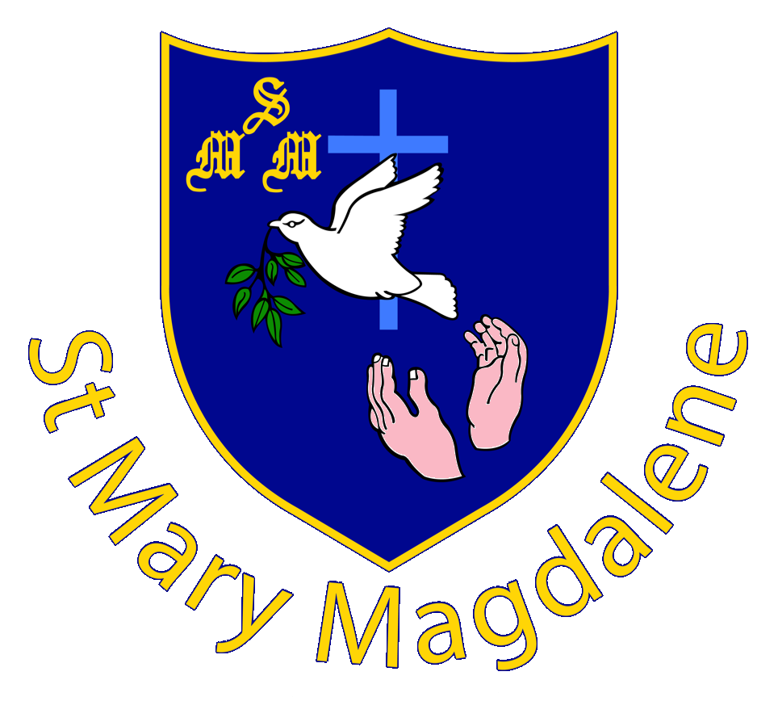
ST MARY MAGDALENE CATHOLIC PRIMARY SCHOOL

APPLICATION FORM
Office Use Only Date received: Date recorded:

As well as filling in the Common Admissions Application Form, provided by Milton Keynes Local Authority, as a Voluntary Aided Catholic School we require this form to be completed also. This is to assist the Admissions Committee of the Governing Body to assess applications for admissions to this school by the criteria set out in the Admission Arrangements. Copies of the Admissions Arrangements are available from the school office. Please return this supplementary form to the school.

Please complete all sections and provide copies of the following:  Full Birth Certificate
● Certificate of Baptism

Please make sure you use CAPITAL LETTERS and write clearly so that we have the correct information
Child’s Surname: |  | Child’s Firstname:
Child’s Gender: |  | Child’s Date of birth:
Child’s address:
including postcode
Father’s name: |  | Father’s contact number:
Father’s work number: |  | Father’s personal email address:
Mother’s name: |  | Mother’s contact number:
Mother’s work number: |  | Mother’s personal email address:

Child’s Religion: |  | Child’s Date of Baptism:
Parish Priest: |  | Minister/Vicar:
Name of Church you attend:
Other denominations should enclose a letter from minister/pastor/vicar etc in support of this application
If your child is starting in year 3 or above, has your child made the sacraments of: |  |  | First Reconciliation ◻  First Holy Communion ◻

Are there are other professionals involved with your child eg speech and language, paediatrician etc – please give details:
Name and address of your child’s current school:

If my child is offered a place at St Mary Magdalene, I understand school uniform is compulsory. I will ensure they attend wearing the correct school uniform and follow the dress code at all times.

Parents/Carers signature:
Date:

