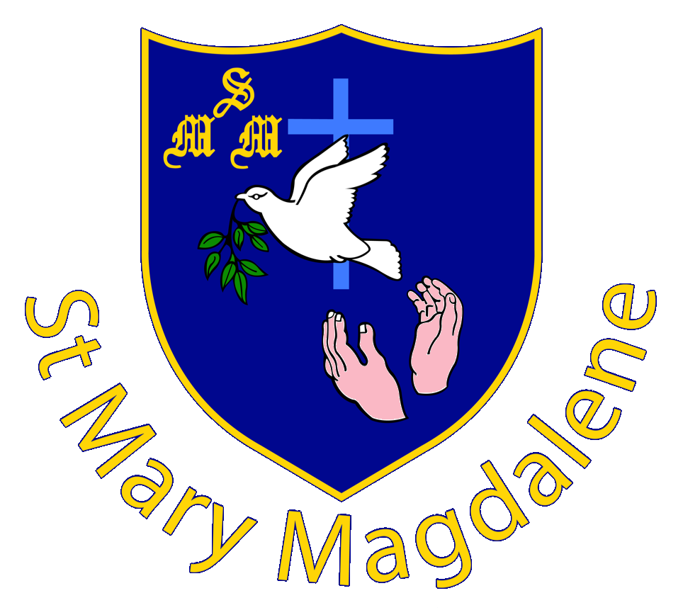
Please complete and return this form with a copy of your child’s birth certificate to the Headteacher, Mrs R Jones, at the school Ardwell Lane, Greenleys, Milton Keynes, MK12 6AY.
ST MARY MAGDALENE CATHOLIC NURSERY
APPLICATION FORM

Please make sure you use CAPITAL LETTERS and write clearly so that we have the correct information

Name of Child for whom admission is sought:
Gender
Child’s date of birth:
Child’s full address inc postcode:

Child’s first language:
Language(s) spoken at home:
Father’s name:
Father’s contact number:
Father’s personal email address:
Mother’s name:
Mother’s contact number:
Mother’s personal email address:
Are you looking for 15 hours or 30 hours?
if unsure this can be discussed at home visit

Child’s present playground and date started/ended:
Please include address

Medical Information
Child’s allergies:
Does your child wear glasses?
Does your child have hearing issues – if yes please give details:
Doctor’s name and surgery address:

Are there are other professionals involved with your child eg speech and language, paediatrician etc – please give details:

Parents/Carers signature:
Date:
Office Use Only Date received: Date recorded:

