Gli hobbies e sport

Print (or write out) the activities on the next pages. Activities get harder with each page. Suggested activity pages for each year group are below. You can, of course, also try the harder activities; they will all help you become great at languages!

For Year 1 and 2 pupils: Try the activities on pages 1 and 2.
For Year 3 and 4 pupils: Also try the activities on pages 3 to 5.
For Year 5 and 6 pupils: Also try the activity on page 6.

Afterwards, see how many words you can remember, revise and try to learn the new vocabulary.

- First of all colour in the pictures and translate the names of the Sports or Hobbies from Italian to English
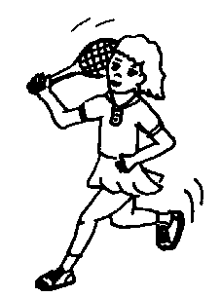  Giocare a tennis | 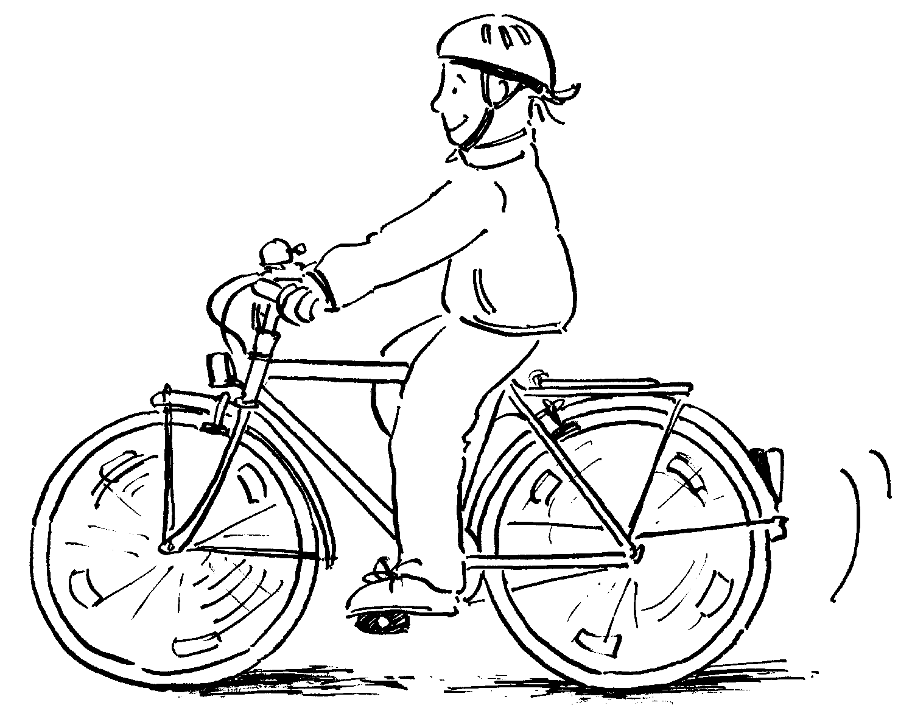  Andare in bicicletta | Suonare il flauto  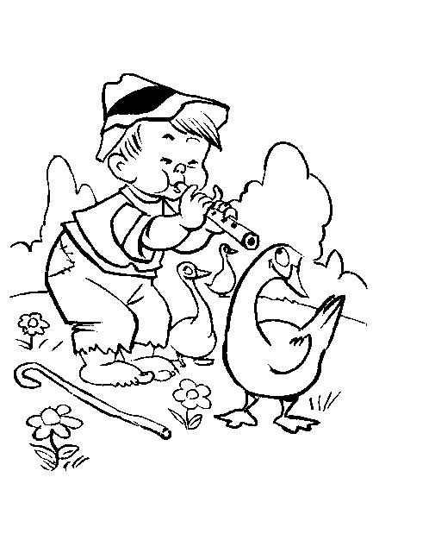 | 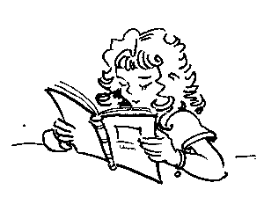  Leggere i libri
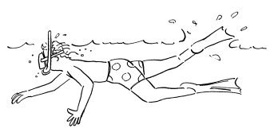  Nuotare | 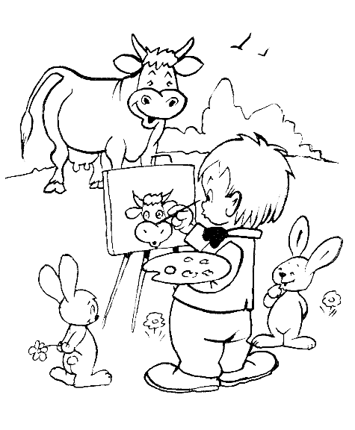  Disegnare | 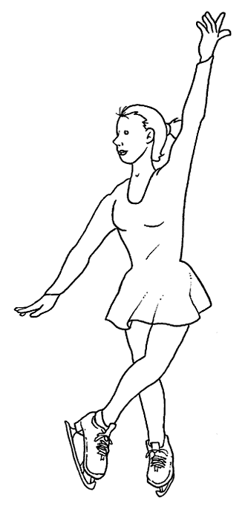  Pattinare | 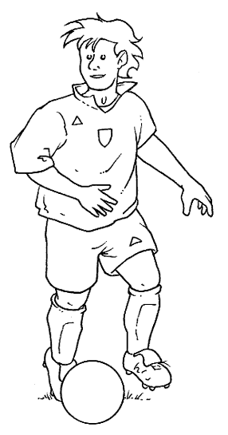  Giocare a calcio

- Match the pictures on page 1 with the dialogue balloons below: Cut out the pictures, stick them in your exercise book and stick the correct dialogue balloons next to them

Mi piace suonare il flauto! (I like to play the flute)

Mi piace andare in bicicletta! (I like to ride my bicycle)
Mi piace leggere i libri! (I like to read books)

Mi piace pattinare sul ghiaccio! (I like to skate on the ice)

Mi piace disegnare! (I like to draw)
Mi piace nuotare nel mare! (I like to swim in the sea)

Mi piace giocare a calcio! (I like to play football!)
Mi piace giocare a tennis! (I like to play tennis)

- Write a phase in the box next to the picture that describes what they are doing.

 | EXAMPLE  Giovanni: mi piace giocare a calcio |  | Anna:………………………
 | Pietro: …………………… |  | Mario:………………………
 | Marco:…………………… |  | Fabia:………………………
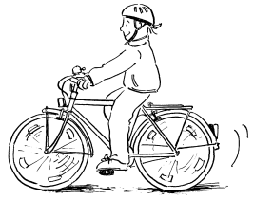 | Serena:………………… |  | Laura:………………………

- Word Search: find the names of objects related to Sports or hobbies in this grid in any direction

g | n | c | m | a | s | c | h | e | r | a
p | i | n | n | e | b | z | r | a | p | o
p | c | c | u | h | i | b | h | j | a | h
a | f | r | a | c | c | h | e | t | t | a
l | l | y | z | f | i | k | c | p | t | h
l | a | e | e | o | c | q | o | a | i | k
o | u | k | s | g | l | i | l | l | n | l
n | t | q | f | l | e | e | o | l | i | i
e | o | p | c | i | t | l | r | i | x | b
g | u | j | h | o | t | x | i | n | q | r
m | a | t | i | t | a | q | l | e | c | o

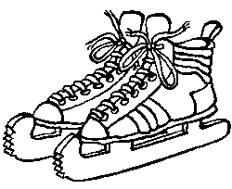pattini | palline | racchettara | pallone
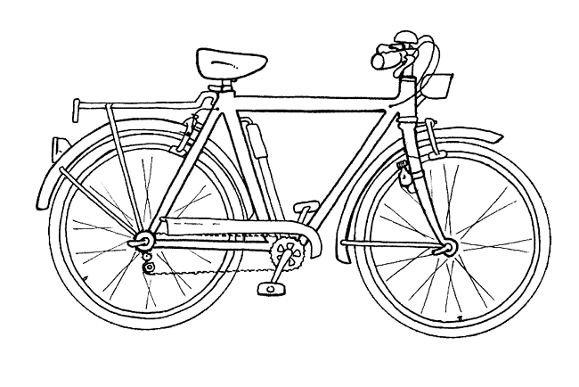bicicletta | 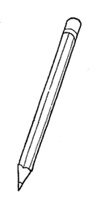matita | 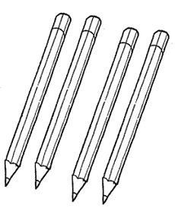colori | 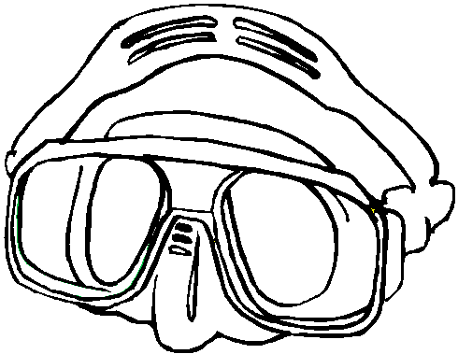maschera
pinne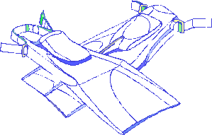 | libro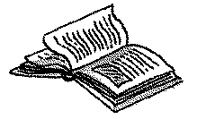 | 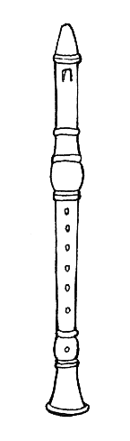flauto | 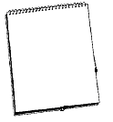foglio

- Match the sport in the pictures with the list in the box on the right of the page
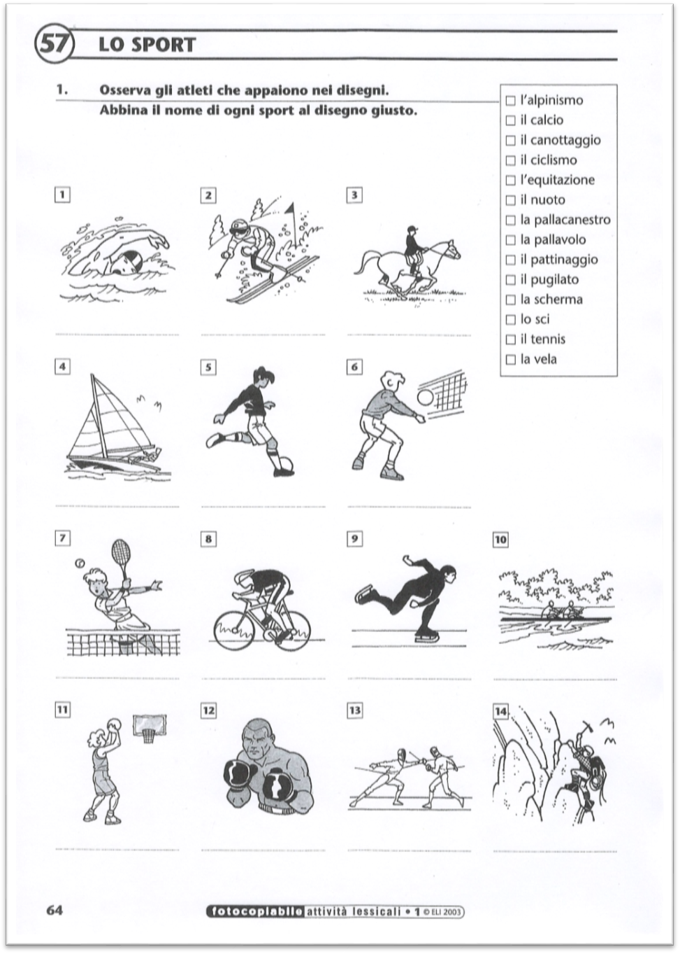

- Sports in Action: Watch the Video in the link below then translate into English the various actions associated with the Sports that you find in the brackets below. Use your dictionary book or on line.

https://www.youtube.com/watch?v=AbV7f1_xuCw
Tennis (dritto; rovescio)
Calcio (cross; testa)
Pallavolo (also; schiaccio)
Basket (stop; tiro)
Salto in alto (piega; salta)
Salto in lungo (corri; salta)
Lancio del disco (giro; lancio)
Tiro con l’arco (mira; tira)
Canoa (destra; sinistra)
Cavallo – equitazione (trotto; galoppo)
Golf (swing; tiro)
Motociclismo (impenno; freno)
Pugilato (destroy; sinistro)
Sci (scendo; piego)
Scherma (finta; affondo)
Nuoto (rana; dorso)

